Week 6 Book Suggestions - Dragon Tales
Anderson County Library Summer Reading Program 2021
The 2021 theme is “Tails & Tales.”

      - Dragon’s fat cat by Dav Pilkey
      - Dragonbreath by Ursula Vernon
      - D is for dragon dance by Ying Chang Compestine
      - You don’t want a dragon by Amy Dyckman
      - Sir Pete the Brave by James Dean
      - Saint George and the dragon by Margaret Hodges
      - Dragons love tacos by Adam Rubin
      - The library dragon by Carmen Agra Deedy
      - Attack of the Underwear Dragon

These are stories your child may like, however, they are not required reading.
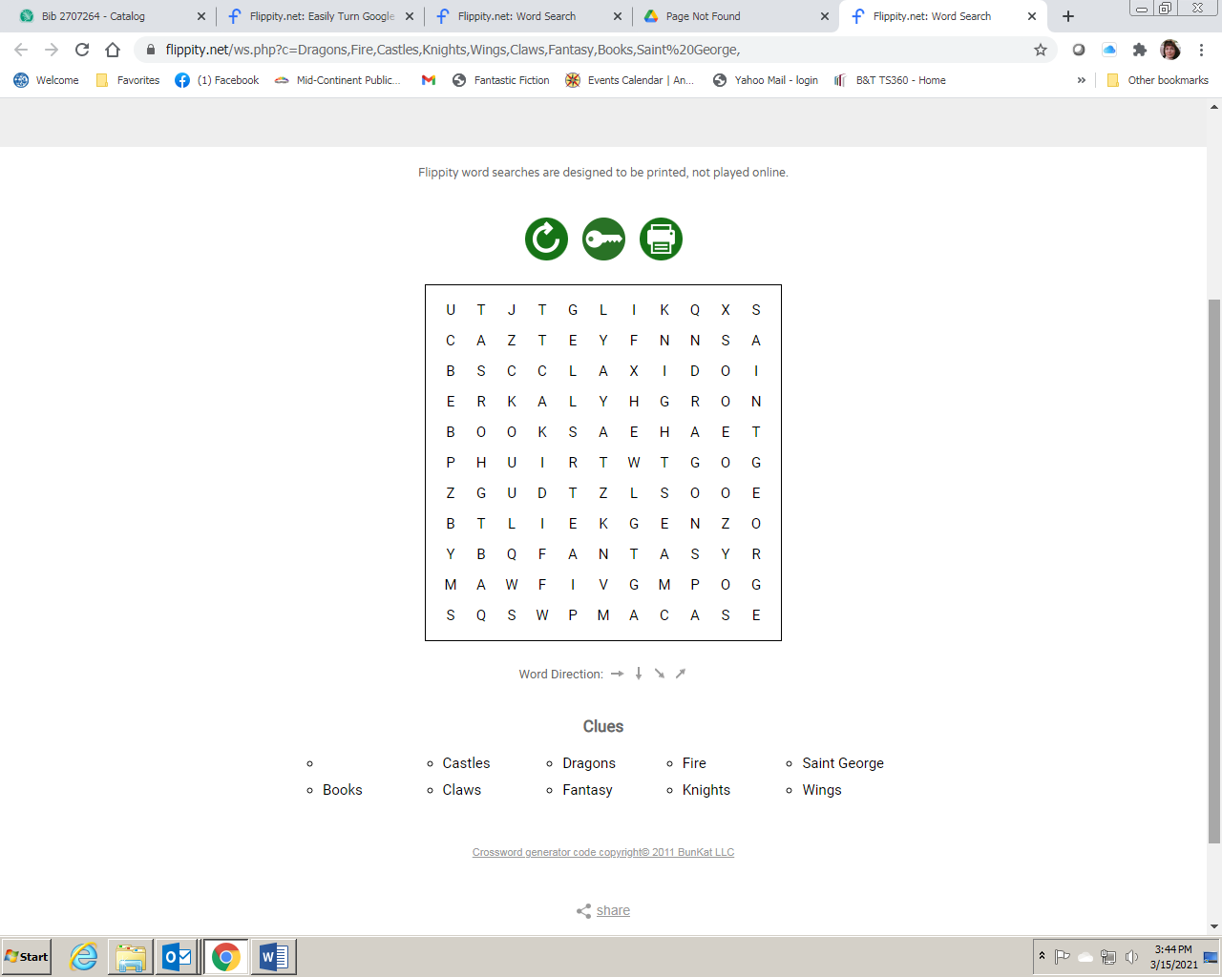
Clues
Claws Saint George
Castles Knights
Books Dragons
Fantasy Fire Wings

Add some movement to your day with this Dragon Dance video! https://www.youtube.com/watch?v=iCgQWb3qg98

Answer Key

