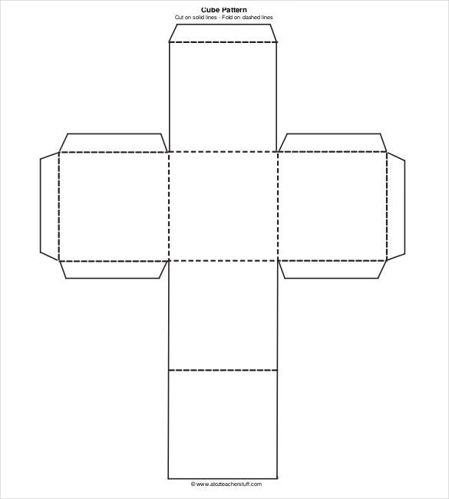
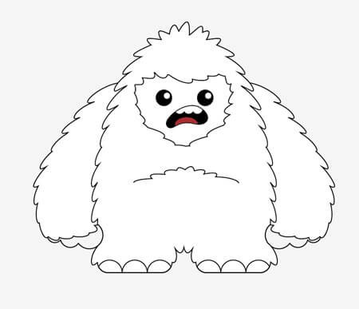
The Yeti! Instructions
Fold along all dotted lines with pictures facing out.
Glue boxes together.
Glue
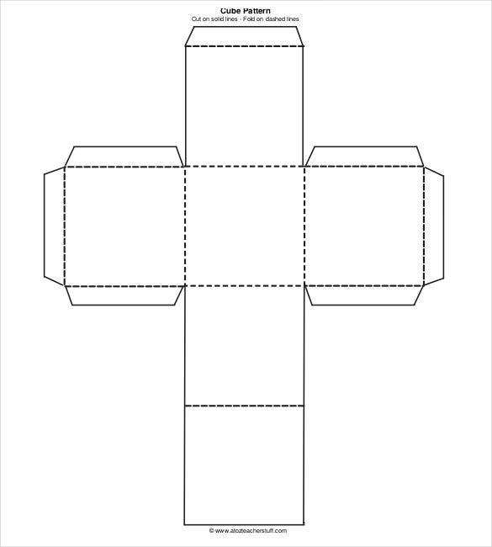
Glue

