Answer key
Across
1. Claw
3. Norbert
5. Fantasy
6. Books
8. Wings

Down
1. Castles
2. Fire
4. Knights
7. Sword

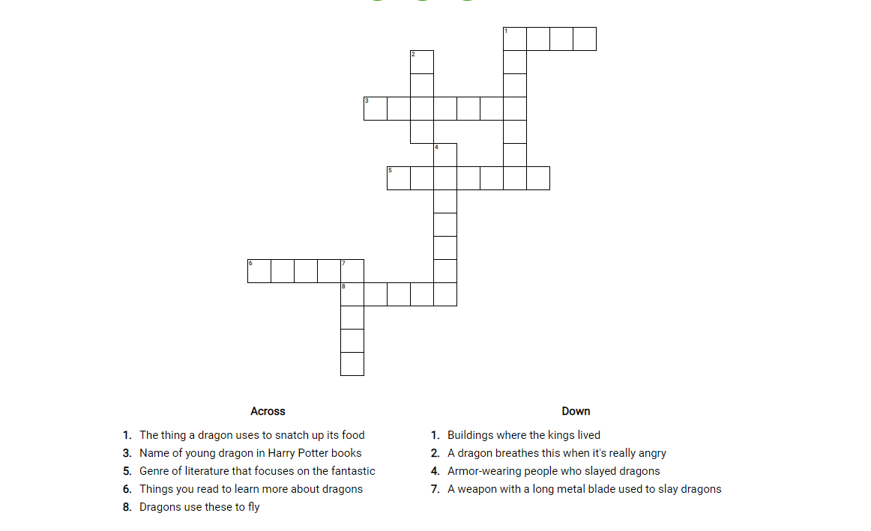
Roaring Dragon Crossword Puzzle

