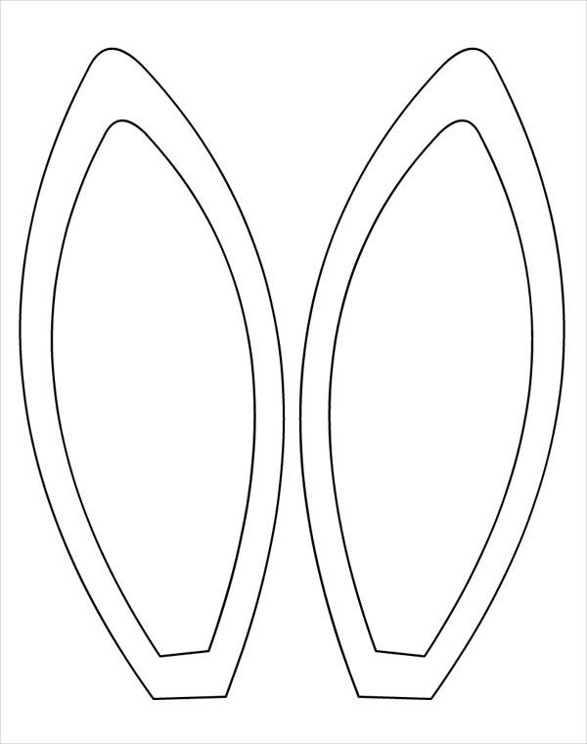
Color the inside of the ears pink
Cut out ears
Tape to Headband (sides of this paper)
Read a book about bunnies to your child

