Instructions:
Cut out all squares.
Glue dog pictures to “Tails and Tales” squares to make playing cards opaque (so you can’t see through them).
Turn all cards dog-side down.
Player 1 turns over two cards. If it’s a match, they go again. If not, the next player goes.
Continue until all matches have been made.
Dalmatian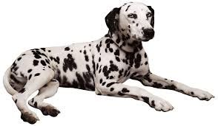 | Chihuahua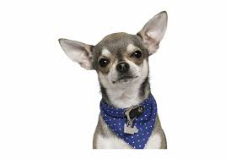 | Corgi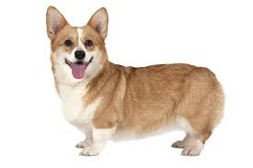
Dachsund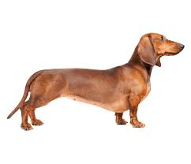 | Beagle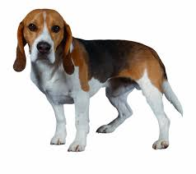 | Poodle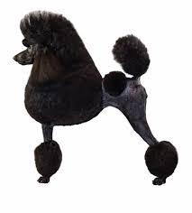
German Shepherd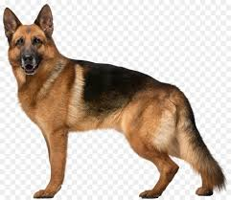 | Pomeranian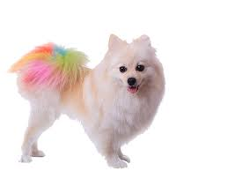 | Husky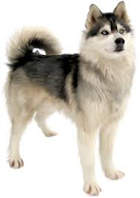
Pug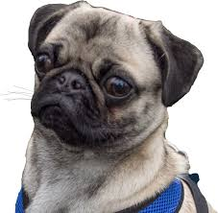 | Golden Retriever | Cocker Spaniel


Dalmatian | Chihuahua | Corgi
Dachsund | Beagle | Poodle
German Shepherd | Pomeranian | Husky
Pug | Golden Retriever | Cocker Spaniel

