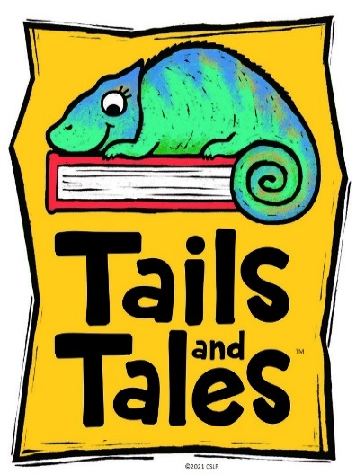

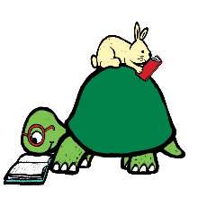 |  | 
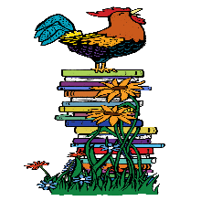

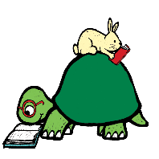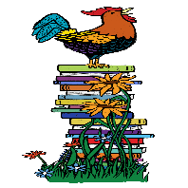

Cut out the four animal pieces and glue them on four different squares on the game board.
Color the rest of the squares with different colors, using at least 3 colors. Color the squares on the cards with the same colors you used on the game board.
Cut out the cards and shuffle them.
Use any small item that fits on the board as a game piece. Some ideas for pieces include dimes, paperclips, etc.

Rules:
Draw a card and move to the next space of a matching color until you reach the end. If an animal is drawn, move to that space regardless of your location on the board. If you are near the end of the board and there are no more colored spaces that match the card drawn, move to the end. You win!

Start
End

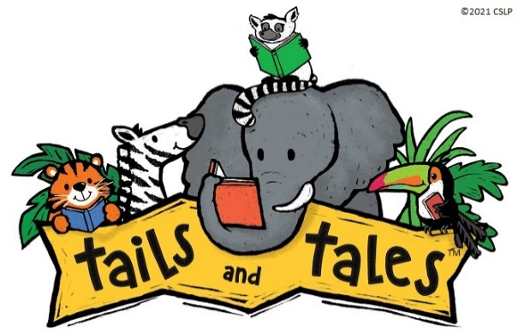
Cards

