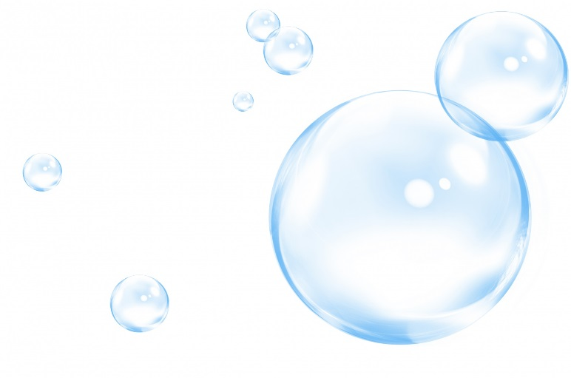
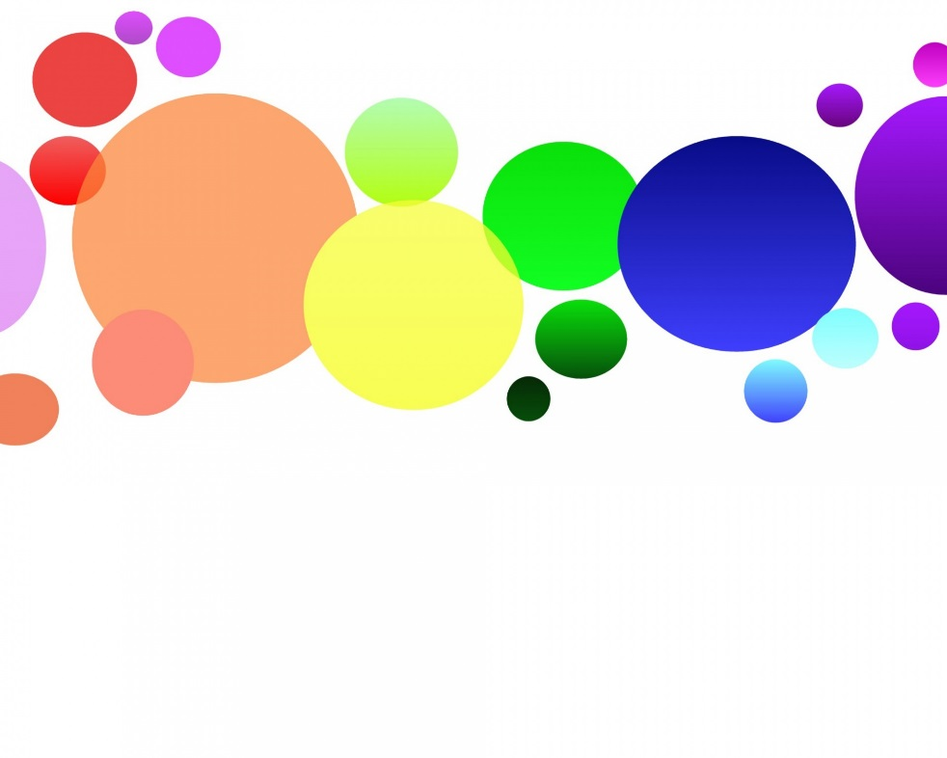
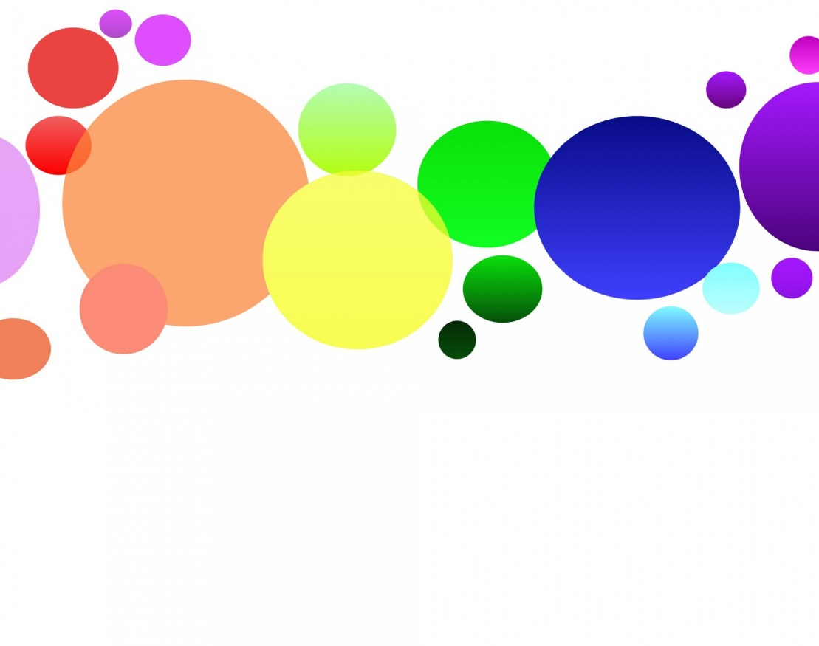
The DIY Lava Lamp
You will need
1 glass container
Water
Vegetable oil
Food coloring
Effervescent tablets

